TABLE 10 FORM FOR CONVERTING A LONG-TERM VISION INTO SHORT-TERM ACTION
ORGANIZING AND MANAGING FARMERS’ GROUPS
61

 | CURRENT SITUATION | SHORT-TERM ACTIVITIES | MEDIUM-TERM ACTIVITIES | LONG-TERM ACTIVITIES | LONG-TERM GOAL
PRODUCTION  POSTHARVEST  MARKETING  BUSINESS SERVICES | Where we are now | In next year | In next 5 years | In next 10–15 years | Where we want to be in 10–15 years

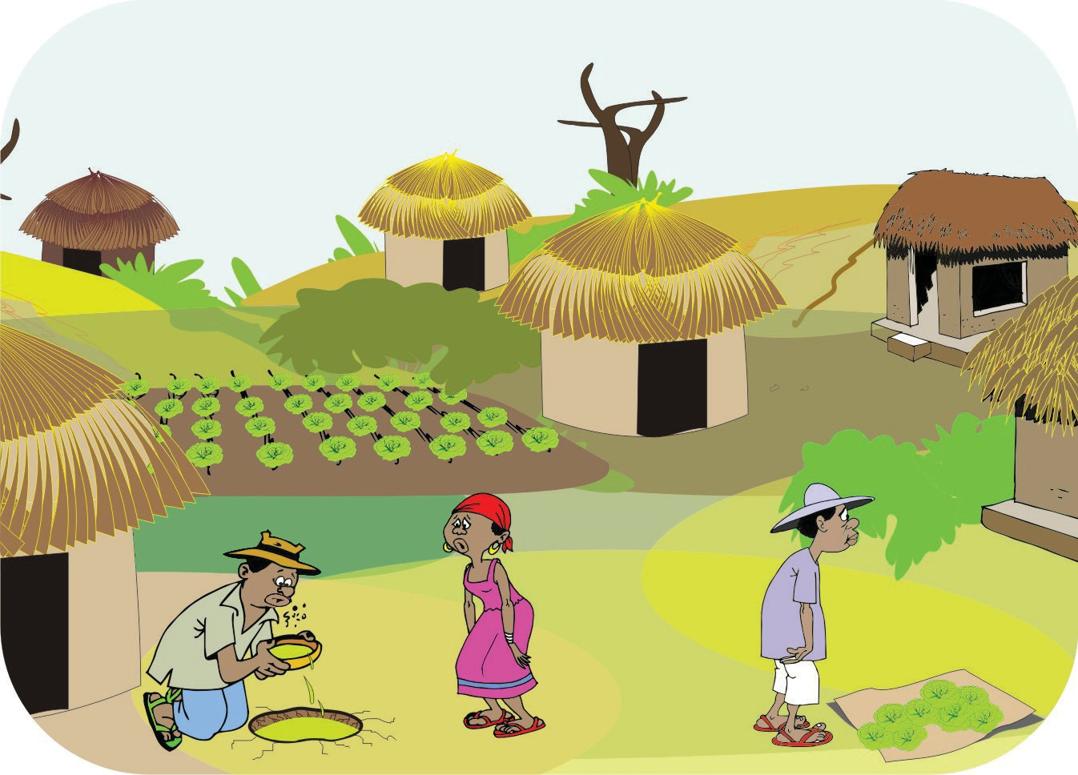
Visioning

Where we are now
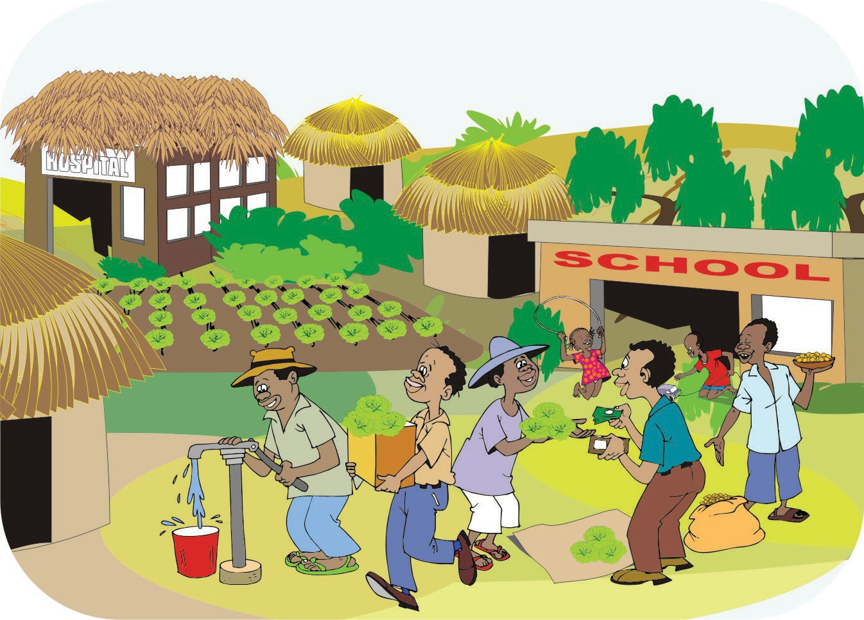
Where we want to be
62 ORGANIZING AND MANAGING FARMERS’ GROUPS

